**M****ethodology for the UNDP Fragility Model**

Dr David Hammond, Director of Research, Institute for Economics and Peace

Alex Vedovi, Research Fellow, Institute for Economics and Peace

Thursday, 24 June 2021

Contents

Contents 1

Background 2

Next Steps for the UNDP-FM 2

Building the Pilot UNDP-FM 4

Sourcing and Collecting Raw Data 4

Indicator Descriptions 6

People Domain 6

Broken Social Contract 7

Economic Inequality 7

Gender 7

Youth 8

Crisis Recovery 8

Violence 9

Health 9

Planet Domain 9

Climate Change 9

Considered Indicators 9

Natural Hazards 9

Natural Resource Degradation 10

Considered Indicators 10

Prosperity Domain 10

Governance Deficit 10

Fragile Cities 11

Economic Stability 11

Digitalisation 11

Considered Indicators 12

Peace Domain 12

Thinking and Working Politically 12

Transborder and Regional Trends 13

UNDP-FM Calculations 13

Data Imputation 13

Indicator Banding 14

Weighting indicators and domains 15

UNDP-FM Calculation Process Table 16

# Background

In 2021 UNDP began a project with the Institute for Economics and Peace (IEP) to build a pilot Fragility Model. Its purpose was to:

1. Be based around the 4P’s of People, Planet, Prosperity and Peace.
2. Use a minimal set of key indicators.
3. Use best practice statistical techniques.
4. Be adaptable to allow for future inclusion of qualitative indicators.

Through expert consultation, the UNDP Fragility Model (UNDP-FM) is currently comprised of 15 core concepts and 34 quantitative indicators. It forms the basis for further expansion in future iterations. Table 1 lists the top 20 most and least fragile countries using this framework.

**Table 1 Indicative Results of the Pilot UNDP-FM**

|  |  |  |  |
| --- | --- | --- | --- |
| **Most Fragile** | **Fragility Score** | **Least Fragile** | **Fragility Score** |
| Somalia | 0.82 | Czech Republic | 0.19 |
| South Sudan | 0.8 | Slovenia | 0.19 |
| Central African Republic | 0.78 | France | 0.19 |
| Yemen | 0.77 | Belgium | 0.19 |
| Democratic Republic of the Congo | 0.77 | Singapore | 0.18 |
| Afghanistan | 0.76 | Canada | 0.17 |
| Chad | 0.73 | Ireland | 0.17 |
| Sudan | 0.71 | Australia | 0.17 |
| Syria | 0.69 | United Kingdom | 0.17 |
| Eritrea | 0.69 | New Zealand | 0.15 |
| Libya | 0.69 | Germany | 0.15 |
| Burundi | 0.68 | Austria | 0.14 |
| Mali | 0.67 | Luxembourg | 0.13 |
| Equatorial Guinea | 0.66 | Iceland | 0.13 |
| Niger | 0.66 | Netherlands | 0.13 |
| Republic of the Congo | 0.65 | Sweden | 0.12 |
| Haiti | 0.65 | Switzerland | 0.12 |
| Myanmar | 0.65 | Denmark | 0.11 |
| Guinea-Bissau | 0.65 | Finland | 0.11 |
| Nigeria | 0.64 | Norway | 0.11 |

# Next Steps for the UNDP-FM

This was a pilot for a UNDP-FM which offers large scope for expansion. Next steps would include:

* Defining and planning for the creation and incorporation of UNDP specific qualitative indicators that could capture expert assessments of different countries.
* Exploring the extent to which these or additional indicators can be disaggregated by age, gender, disability, etc.
* Exploring ways of building on existing indicators. For example, the Igarapé Fragile Cities index, being subnational in nature, offers a unique point of differentiation for the UNDP-FM. However, this was discontinued in 2015. The methodology is easily updated by IEP if required.
* Digitalisation is another point of differentiation of the UNDP-FM. With disinformation being a major threat to democracy, it is timely to explore the “good” and “bad” aspects of digitalisation. IEP has tried to capture this with positive and negative indicators in the UNDP-FM which can be easily expanded and explored more fully.
* The success of any fragility model lies in the ease in which it is accessed and accessible. UNDP’s Crisis Risk Dashboard offers the ideal platform to standardise and disseminate the UNDP-FM through data, visualisation and analysis. How to incorporate the UNDP-FM into the Crisis Risk Dashboard and UNDP’s workflow will require further consideration.
* The UNDP-FM has been constructed using Principal Components analysis, which can also be extended to clustering countries with similar fragilities. This could be developed to a taxonomy of fragility built specifically for UNDP around the 4P’s. Preliminary clustering done by IEP is shown in Figure 1 which identifies the following three distinct fragile clusters:
  + Cluster A (Yemen, Afghanistan, Syria): Major fragilities include Transborder Conflict, Climate Change, Health and Violence
  + Cluster B (Sub-Saharan Africa): Major fragilities include Health, Economic Stability, Crisis Recovery and Governance Deficit
  + Cluster D (Egypt, Turkey, LatAM): Major fragilities include Climate Change, Transborder Conflict, Thinking and Working Politically and Violence

**Figure 1 UNDP-FM clustering: A taxonomy of the 4P’s**

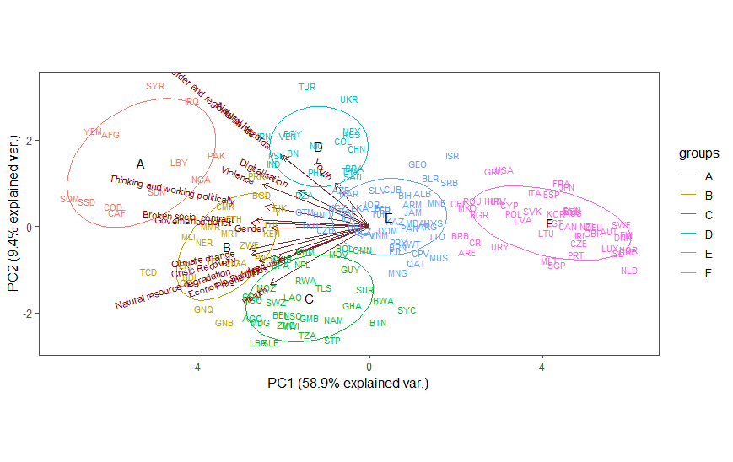

# Building the Pilot UNDP-FM

The development of the UNDP-FM has followed the general index construct process:

1. Sourcing and collating raw data
2. Filling and imputing data gaps
3. Banding
4. Weighting using Principal Components Analysis (PCA)
5. Aggregating into an index

## Sourcing and Collecting Raw Data

The UNDP-FM is designed to measure fragility based on four domains:

* People
* Planet
* Prosperity
* Peace

These domains, and the indicators within each, were decided upon through consultation with the UNDP Expert Panel meetings. Indicators highlighted in red are those that have been used in this pilot but would need revisiting due to (1) uncertainty of future updates (2) lack of country coverage. Table 2 provides a summary of these domains and indicators and provides indicators which can also be disaggregated by gender

**Table** **2 UNDP-FM Domains and Indicators**

|  |  |  |  |  |  |  |
| --- | --- | --- | --- | --- | --- | --- |
| Domain | Concept | Indicators | Source | Number of Countries | Time Series | Gender Disaggregation |
| People | Broken Social Contract | Access to Essential Services | Social Progress Imperative | 194 | 2014-2019 |  |
| Broken Social Contract | Public Trust in Politicians, 1-7 (best) | WEF | 152 | 2007-2017 |  |
| Broken Social Contract | Group Grievance | Fund For Peace | 178 | 2006-2020 |  |
| Broken Social Contract | Perceptions of Corruption | Transparency International | 180 | 2012-2020 |  |
| Economic Inequality | Pre-Tax National Income (Top 10%) | World Inequality Database | 176 | 2010-2019 | Yes |
| Gender | Women, Business and Law Index Score | World Bank, Women Business and the Law database | 190 | 1971-2021 |  |
| Gender | Gender Disparities in Development | UNDP Gender Development Index | 167 | 2019 |  |
| Gender | Prevalence of Violence Against Women and Girls | UN – SDG 5.2 | 107 (missing countries given regional averages) | 2012-2017 |  |
| Gender | Proportion of Women in Parliament | Inter-Parliament Union | 193 | 1994-2018 |  |
| Youth | Confidence in National Government – Yes (15-24 yo) | Gallup World Poll | 153 | 2006-2018 | Yes |
| Youth | Youth Not in School or Employment | UNDP | 180 | 2019 | Yes |
| Crisis Recovery | Lack of Coping Capacity | INFORM | 191 | 2011-2020 |  |
| Violence | Safety and Security (GPI) | IEP | 163 | 2008-2020 |  |
| Health | Infant Mortality Rates per 1000 | UNDP | 187 | 2018 |  |
| Health | Maternal Mortality per 1000 | UNDP | 173 | 1985-2018 |  |
| Planet | Climate change | Climate Risk and Adaptation Capacity | Notre Dame Global Adaptation Initiative | 192 | 1995-2018 |  |
| Natural Hazards | Hazard and Exposure | INFORM | 191 | 2011-2020 |  |
| Natural resource degradation | Environmental Performance Index | Yale | 180 | 2020 |  |
| Natural resource degradation | Adjusted Savings: Natural Resources Depletion (% of GNI) | World Bank | 231 | 1970-2018 |  |
| Prosperity | Governance deficit | Well-Functioning Government | IEP | 163 | 20010-2020 |  |
| Fragile Cities | Urban Population Growth (annual %) | World Bank | 261 | 1961-2019 |  |
| Fragile Cities | Fragile Cities Score | Igarapé Institute | 154 | 2000-2015 |  |
| Economic Stability | Credit Rating | S&P | 204 | 1989-2021 |  |
| Digitalisation | E-Government Development Index: Online Service Index | UN | 213 | 2013-2020 |  |
| Digitalisation | Global Cybersecurity Index | ITU | 195 | 2014-2017 |  |
| Digitalisation | E-Participation Index | UN | 213 | 2013-2020 |  |
| Digitalisation | Use of Social Media to Organise Offline Violence | VDEM | 179 | 2000-2019 |  |
| Digitalisation | Government Social Media Monitoring | VDEM | 179 | 2000-2019 |  |
| Digitalisation | Digital Adoption Index | World Bank | 180 | 2014-2016 |  |
| Peace | Thinking and Working Politically | Civil Society Participation | IDEA | 178 | 2006-2020 |  |
| Thinking and Working Politically | Rule of Law | World Bank | 214 | 1996-2019 |  |
| Thinking and Working Politically | Voice and Accountability | World Bank | 214 | 1996-2019 |  |
| Thinking and Working Politically | Deliberative democracy index | VDEM | 183 | 1900-2019 |  |
| Transborder and Regional Trends | Ongoing Conflict | IEP | 163 | 2008-2020 |  |

# Indicator Descriptions

## People Domain

The People domain captures the following concepts:

* Broken Social Contract
* Economic Inequality
* Gender Inequality
* Youth
* Crisis Recovery
* Violence
* Health

### Broken Social Contract

The Broker Social Contract concept aims to capture faith in institutions, corruption and vertical inequality. It does this through the following indicators.

***Access to Essential Services:***

This indicator is taken from the Social Progress Imperative’s Social Progress Index and draws on the Universal Health Coverage (UHC) Index of the Institute for Health Metrics and Evaluation. The UHC Index measures the coverage of nine tracer interventions and risk standardized death rates from 32 causes amenable to personal healthcare.[1]

***Public Trust in Politicians:***

Taken from the World Economic Forum’s Global Competitive Index, this indicator draws on responses to the survey question “In your country, how do you rate the ethical standards of politicians?”, to which business executive respondents reply on a seven-point scale.[2]

***Group Grievance:***

Taken from Fund for Peace’s Fragile States Index, this indicator focuses on divisions and schisms between different groups within a society – particularly divisions based on social or political characteristics – and their role in access to services or resources, and inclusion in the political process.[3]

***Perceptions of Corruption:***

This indicator is taken from Transparency International’s Corruption Perceptions Index, which scores and ranks countries and territories based on how corrupt their public sectors are perceived to be by experts and business executives. The Corruption Perceptions Index is a composite index, a combination of 13 surveys and assessments of corruption, collected by a variety of reputable institutions.[4]

### Economic Inequality

The Inequality concept aims to capture the unequal distribution of income across a national community. It does this through the following indicator.

***Pre-Tax National Income (Top 10%):***

Using figures from the World Inequality Database, this indicator expresses the share of the national pre-tax income that goes to the top 10 per cent of earners in a country.

### Gender

The Gender concept aims to capture the participation, inequality and interpersonal violence that exists for women in a national community. It does this through the following indicators.

***Women, Business and Law Index Score:***

Taken from the World Bank’s Women, Business and Law database, this index measures how laws and regulations affect women’s economic opportunity. Overall scores are calculated by taking the average score of each of the eight areas (Going Places, Starting a Job, Getting Paid, Getting Married, Having Children, Running a Business, Managing Assets and Getting a Pension), with 100 representing the highest possible score.

***Gender Disparities in Development:***

Drawing on UNDP’s Gender Development Index, this indicator measures gender gaps in human development achievements by accounting for disparities between women and men in three basic dimensions of human development – health, knowledge and living standards – using the same component indicators as in the Human Development Index.

***Prevalence of Violence against Women and Girls:***

Using UN data from SDG 5.2, this indicator measures the proportion of women and girls aged 15 years and older that have been subjected to physical, sexual or psychological violence by a current or former intimate partner in the previous 12 months, by form of violence and age. The data for SDG 5.2 has categorisations for age with different countries reporting on different age brackets. To maximise the number of countries, IEP has averaged these age brackets within countries to provide a dataset of 107 nations. The remaining countries have been assigned the regional average.

***Proportion of Women in Parliament:***

Using data from the Inter-Parliamentary Union, this indicator takes the average of the proportion of women who hold seats in either the Upper or Lower Houses of parliament.[5]

***Gender Disaggregation in Other Indicators:*** *In addition to the gender specific indicators included in the UNDP-FM, three additional indicators can also be disaggregated by gender for future analysis:*

1. Pre-Tax National Income (Top 10%)
2. Confidence in National Government – Yes (15-24 yo)
3. Youth Not in School or Employment

### Youth

The Youth concept aims to capture social challenges and fragilities strongly associated with young people. It does this through the following indicators.

***Confidence in National Government***

Drawing on data from the Gallup World Poll, this indicator expresses the percentage of respondents that answered “yes” to the question “Do you have confidence in the national government?”[6]

***Youth Not in School or Employment***

This indicator measures the percentage of young people (by most definitions between the ages of 15 and 24) who are not integrated into any form of employment, education or training.[7]

### Crisis Recovery

The Crisis Recovery concept aims to capture the capacity of a society to recover from crises of different kinds. It does this through the following indicator.

***Lack of Coping Capacity***

Taken from the INFORM Risk Index produced by the European Commission, this indicator expresses the capacity of a country to cope with disasters in terms of formal, organized activities and the effort of the country’s government as well as the existing infrastructure which contribute to the reduction of disaster risk.[8]

### Violence

The Violence concept aims to capture the prevalence of violence and the fear of violence within a society. It does this through the following indicator.

***Safety and Security***

Taken from the Global Peace Index of the Institute for Economics and Peace, this indicator expresses levels of safety and security within a society. A composite of ten metrics, it includes rates of homicide, violent crime and incarceration, as well as qualitative measures such as levels of perceived criminality and political instability.[9]

### Health

The Health concept aims to capture the health status and outcomes of different national communities. It does this through the following indicators.

***Infant Mortality Rates per 1000***

Drawing on UNDP data, this indicator represents the probability in a country of a child dying between birth and exactly age five, expressed per 1,000 live births.[10]

***Maternal Mortality Rates per 1000***

Drawing on data collected UNDP for the Human Development Index, this indicator consists of the rates by country of death due complications from pregnancy or childbirth, expressed per 1,000 live births.

## Planet Domain

The Planet domain captures the following concepts:

* Climate Change
* Natural Hazards
* Natural Resource Degradation

### Climate Change

The Climate Change concept aims to capture the threats associated with changes in the climate. It does this through the following indicator.

***Climate Risk and Adaptation Capacity***

Taken from the Notre Dame Global Adaptation Initiative’s Country Index, this indicator summarises a countries’ vulnerabilities to climate change and other global challenges in combination with their readiness to improve resilience.

### Considered Indicators

**Germanwatch Climate Risk Index:** This indicator consists of Germanwatch’s Global Climate Risk Index, which measures the extent to which countries have been affected to extreme weather events. These measures should be understood by countries as warnings about their exposure and vulnerability in order to be prepared for more frequent and/or more severe events in the future.[11] This was dropped on recommendation of UNDP in favour of the Notre Dame indicator.

### Natural Hazards

The Natural Hazards concept aims to capture the risk of hazard events affecting a society. It does this through the following indicator.

***Hazard and Exposure***

Taken from the INFORM Risk Index produced by the European Commission, this indicator reflects the probability of physical exposure associated with specific hazards. There is no risk if there is no physical exposure, no matter how severe the hazard event is. Therefore, the hazard and exposure dimensions are merged into hazard and exposure dimension.[12]

### Natural Resource Degradation

The Natural Resource Degradation concept aims to capture the degree to which environmental systems have been harmed, disrupted or destroyed in different countries. It does this through the following indicators.

***Environmental Performance Index***

This indicator is taken from Yale University’s Environmental Performance Index (EPI), which provides a data-driven summary of the state of sustainability around the world. Using 32 performance indicators across 11 issue categories, the EPI ranks 180 countries on environmental health and ecosystem vitality.[13]

***Adjusted Savings: Natural Resources Depletion (% of GNI)***

Calculated by the World Bank, this indicator expresses natural resource depletion as the sum of net forest depletion, energy depletion and mineral depletion.[14]

### Considered Indicators

**Planetary Human Development Index:** A measure of the level of development compared to burden on the planet. While important, the fact that more developed countries place a larger burden on the planet is not a traditional measure of domestic fragility.

**Connectivity Indicators (Internet Access etc**): Considered but not included as these are included implicitly in the indicators selected in the UNDP-FM.

## Prosperity Domain

The Prosperity domain captures the following concepts:

* Governance Deficit
* Fragile Cities
* Economic Stability
* Digitalisation

### Governance Deficit

The Governance Deficit concept aims to capture the degree to which countries’ public institutions fulfil – or fail to fulfil – their obligations to citizens. It does this through the following indicator.

***Well-Functioning Government***

Taken from the Positive Peace framework of the Institute for Economics and Peace, this indicator measures the degree to which a government delivers high-quality public and civil services, engenders trust and participation, demonstrates political stability and upholds the rule of law. It is calculated based on three sources: the Political Democracy Index of the Economist Intelligence Unit, World Bank estimates of Government Effectiveness and World Bank estimates of the Rule of Law.[15]

### Fragile Cities

The Fragile Cities concept aims to capture the threats to the sound functioning of cities and the wellbeing of their inhabitants. It does this through the following indicators.

***Urban Population Growth (Annual %)***

This indicator expresses the growth in urban populations – increases in people living in urban areas as defined by national statistical offices. It is calculated using World Bank population estimates and urban ratios from the United Nations World Urbanization Prospects.[16]

***Fragile Cities Score***

This indicator consists of the Igarapé Fragile City scores, which represent an aggregation of urban risks across a wide spectrum of social, economic, environmental and climactic areas. The scores draw on 11 metrics for measuring the ability of city-based institutions to deliver basic conditions of livability, comprising rates of violence, exposure to disaster risk, levels of inequality and rates of electricity penetration, among other measures.[17]

### Economic Stability

The Economic Stability concept aims to capture the solidity of countries’ financial circumstances and practices. It does this through the following indicator.

***Credit Rating***

This indicator consists of the S&P Global Ratings, which are forward looking opinions about a country issuer’s relative creditworthiness.[18]

### Digitalisation

The Digitalisation concept aims to capture the degree of adoption of digital technologies within a society. It does this through the following indicators.

***E-Government Development Index: Online Service Index***

This indicator draws on United Nations’ measures of a government’s capability and willingness to provide services and communicate with its citizens electronically.[19]

***Global Cybersecurity Index***

This indicator consists the International Telecommunication Union’s Global Cybersecurity Index (GCI), which measures the commitment of countries to cybersecurity at a global level. As cybersecurity has a broad field of application, cutting across many industries and various sectors, each country’s level of development or engagement is assessed along five pillars – (i) Legal Measures, (ii) Technical Measures, (iii) Organizational Measures, (iv) Capacity Building, and (v) Cooperation – and then aggregated into an overall score.[20]

***E-Participation Index***

This indicator consists of the E-Participation Index (EPI), a supplementary index to the United Nations’ E-Government Survey. The E-Government Survey focuses on the use of online services to facilitate provision of information by governments to citizens (“e-information sharing”), interaction with stakeholders (“e-consultation”) and engagement in decision-making processes (“e-decision making”).[21]

***Use of Social Media to Organise Offline Violence***

This indicator draws on responses to Varieties of Democracy’s survey question “How often do people use social media to organize offline violence?”, to which respondents can reply that such cases occur “frequently”, “sometimes” or “never” in a given country.[22]

***Government Social Media Monitoring***

This indicator draws on responses to Varieties of Democracy’s survey question “How comprehensive is the surveillance of political content in social media by the government or its agents?”, to which respondents in different countries can reply that such surveillance is “extremely comprehensive”, “mostly comprehensive”, “somewhat comprehensive”, “limited” or that such surveillance happens “not at all, or almost not at all”.[23]

***Digital Adoption Index***

This indicator consists of the World Bank’s Digital Adoption Index (DAI), which is a composite index measuring the spread of digital technologies within and across countries. It measures the depth and breadth of adoption of digital technologies in 171 countries, spanning every region and income group.[24]

### Considered Indicators

Economic Complexity Index (Harvard University): A measure of diversification of an economy. Not included in favour of Standard’s and Poor Credit Rating.

## Peace Domain

The Peace domain captures the following concepts:

* Thinking and Working Politically
* Transborder and Regional Trends

### Thinking and Working Politically

The Thinking and Working Politically concept aims to capture the degree to which development endeavours involve strong political analysis, attention to local context and flexibility in program design and implementation. It does this through the following indicators.

***Civil Society Participation***

Drawing on data from International IDEA, this indicator measures the extent to which organised, voluntary, self-generating and autonomous social life is dense and vibrant in a given country.[25]

***Rule of Law***

This indicator consists of data compiled by the World Bank and captures perceptions of the extent to which agents have confidence in and abide by the rules of society, and in particular the quality of contract enforcement, property rights, the police, and the courts, as well as the likelihood of crime and violence.[26]

***Voice and Accountability***

This indicator consists of data compiled by the World Bank and captures perceptions of the extent to which a country's citizens are able to participate in selecting their government, as well as freedom of expression, freedom of association, and a free media.[27]

***Deliberative Democracy Index***

The deliberative principle of democracy focuses on the process by which decisions are reached in a polity. A deliberative process is one in which public reasoning focused on the common good motivates political decisions—as contrasted with emotional appeals, solidary attachments, parochial interests, or coercion. According to this principle, democracy requires more than an aggregation of existing preferences. There should also be respectful dialogue at all levels—from preference formation to final decision—among informed and competent participants who are open to persuasion. To make it a measure of not only the deliberative principle but also of democracy, the index also takes the level of electoral democracy into account.[28]

### Transborder and Regional Trends

The Transborder and Regional Trends concept aims to capture cross border conflict, crime and international relations. Due to the lack of a reliable source for transborder crime and international relations, the UNDP-FM captures this concept through the following indicator.

***Ongoing Conflict***

This indicator draws on data from IEP and provides a measure of intensity of internal and external conflict. [29]

# UNDP-FM Calculations

## Data Imputation

The issue of data gaps is a common challenge to creating an index. Not all indicators have data points for each country in the UNDP-FM. IEP has employed the best practice techniques listed in Table 4 to deal with data gaps.[30]

**Table 4 Data Imputation Methods Applied in the UNDP-FM**

|  |  |  |
| --- | --- | --- |
| **Imputation method** | **Description** | **Application in the 2020 YDI** |
| Time series imputation | Replace missing values using linear interpolation | IEP uses this method when at least two data points exist in a time series for an indicator-country pair, to estimate data for unreported years.  Similarly, when only one year of data is available for all countries, the values for that year are used for all years in the index. |
| Hot deck imputation | Replacing the missing value with a KNN imputation. KNN is an algorithm that is useful for matching a point with its closest k neighbours in a multi-dimensional space. It can be used for data that are continuous, discrete, ordinal and categorical which makes it particularly useful for dealing with missing data. The NI fills in data gaps using the 5 most similar countries to impute a value. | IEP uses this method for data that is not available for all countries. |

## Indicator Banding

In order to aggregate the incommensurable indicators, all indicators have been banded (normalised). This means each indicator is scaled to a score ranging between 0 and 1, relative to the initial global range. Appropriate minimum and maximum values are, therefore, chosen for each indicator so that any values below the minimum are assigned 0 and values above the maximum are assigned 1. All other values are scaled between 0 and 1, equivalent to their position in the original minimum-maximum range. Depending on the nature of the data, the banding process can take slightly different forms.

For example, for the access to essential services indicator, a higher score reflects a more desirable situation. Therefore, in this case, the banding process has assigned the largest data point a value of 1. Conversely, the lowest data point in the indicator has been assigned a value of 0, while all other data are scaled relative to these two points. This process is referred to as forward banding. On the other hand, a lower score in the mortality indicator reflects a more desirable situation. In this case, the data are reverse banded, so the lowest value is assigned 1 while the highest is assigned 0.

Therefore, for year *y*, a forward banded score is calculated for indicator *i* by Equation 1. A reverse banded score is calculated using Equation 2.

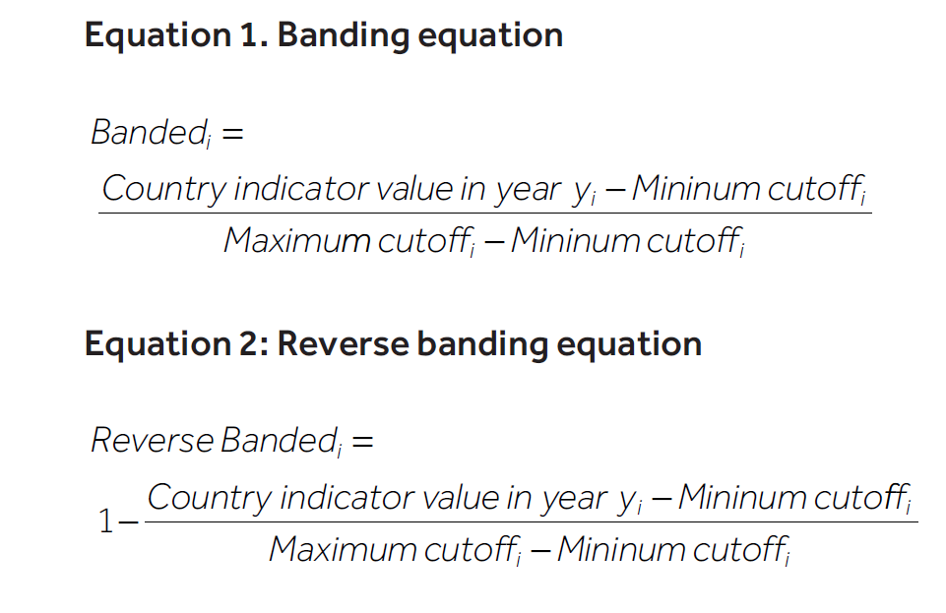

Table 5 shows which banding equation has been used for each indicator. The “Concept Score” is calculated per country as being the average of each banded input indicator.

## Weighting indicators and domains

Table 5 shows the indicators and respective weights applied in the UNDP-FM. These have been statistically derived using Principal Components Analysis (PCA). The objective of PCA is to explain the variance of the observed data through a few linear combinations of the original data. Many fragility indicators are conceptually distinct but correlated. Because of this, much of the data’s variation can often be accounted for by a small number of variables. Using PCA to determine weights is one way to ensure that the final index captures the most unique ways of differentiating countries using the underlying data. The UNDP-FM weights for each concept are shown in Table 5.

While statistically valid, the use of PCA can create some communication issues. For example, in Table 5, Youth is weighted lower than the other concepts. However, this is notbecause this concept is not important, but more of a reflection of the “new” information this data provides to the overall framework. The PCA weights suggest that the differences between countries in the Youth concept are captured, quantitatively at least, through the other indicators. The final scores obtained from PCA have the advantage of guaranteeing that the countries are differentiated as much as they can be from the underlying data.

## UNDP-FM Calculation Process Table

Table 5 summarises the different stages of the calculation of the UNDP-FM.

**Table 5 Calculation Stages for the UNDP-FM**

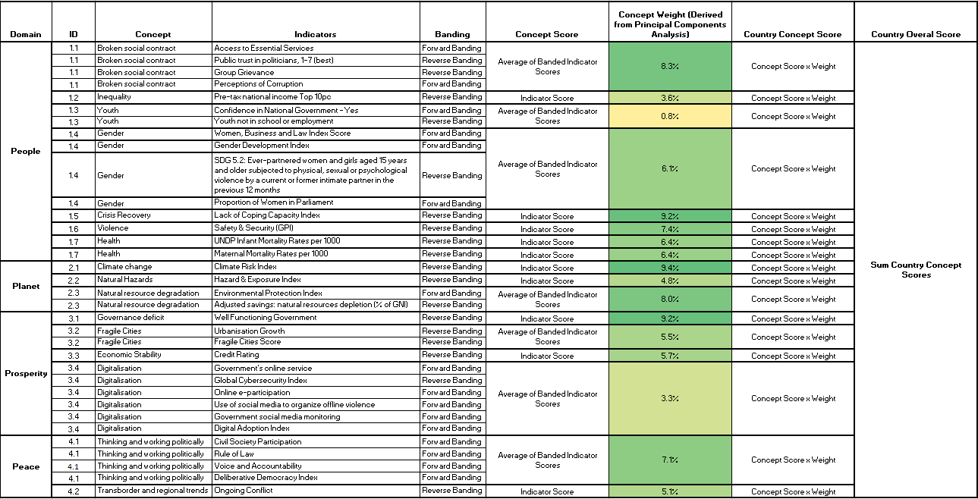

1. <https://www.socialprogress.org/static/1aa2d19690906eb93c6cdb281e5ee68b/2020-social-progress-index-methodology.pdf>
2. <http://reports.weforum.org/pdf/gci-2017-2018-scorecard/WEF_GCI_2017_2018_Scorecard_EOSQ041.pdf>
3. <https://fragilestatesindex.org/indicators/c3/>
4. <https://images.transparencycdn.org/images/2020_CPI_FAQs_ENv2.pdf>
5. <http://archive.ipu.org/wmn-e/classif.htm>
6. <https://www.oecd-ilibrary.org/docserver/gov_glance-2017-76-en.pdf?expires=1619478016&id=id&accname=guest&checksum=2CA0C01A1CBEB9E8CC3B4EAB550170AE>
7. <https://www.md.undp.org/content/dam/moldova/docs/Publications/Inclusion_youth_NEET_EN_web.pdf>
8. <https://drmkc.jrc.ec.europa.eu/inform-index/InDepth/Methodology>
9. <https://www.visionofhumanity.org/wp-content/uploads/2020/10/GPI_2020_web.pdf>
10. <http://hdr.undp.org/en/content/under-five-mortality-rate-1000-live-births>
11. <https://germanwatch.org/sites/default/files/Global%20Climate%20Risk%20Index%202021_1.pdf>
12. <https://drmkc.jrc.ec.europa.eu/inform-index/InDepth/Methodology>
13. <https://epi.yale.edu/>
14. <https://databank.worldbank.org/metadataglossary/world-development-indicators/series/NY.ADJ.DRES.GN.ZS>
15. <https://www.visionofhumanity.org/wp-content/uploads/2020/10/PPR-2019-web.pdf>
16. <https://datacatalog.worldbank.org/urban-population-growth-annual>
17. <https://igarape.org.br/en/o-que-torna-uma-cidade-fragil/>
18. <https://www.spglobal.com/ratings/en/about/intro-to-credit-ratings>
19. <https://www.ifo.de/DocDL/dicereport412-db2.pdf>
20. <https://www.itu.int/en/ITU-D/Cybersecurity/Pages/global-cybersecurity-index.aspx>
21. <https://publicadministration.un.org/egovkb/en-us/About/Overview/E-Participation-Index>
22. <https://papers.ssrn.com/sol3/papers.cfm?abstract_id=3557877>
23. <https://papers.ssrn.com/sol3/papers.cfm?abstract_id=3557877>
24. <https://pubdocs.worldbank.org/en/587221475074960682/WDR16-BP-DAI-methodology.pdf>
25. <https://www.idea.int/news-media/news/space-civil-society-really-shrinking>
26. <https://datacatalog.worldbank.org/rule-law-number-sources>
27. <https://datacatalog.worldbank.org/voice-and-accountability-estimate>
28. <https://papers.ssrn.com/sol3/papers.cfm?abstract_id=3557877>
29. <https://www.visionofhumanity.org/wp-content/uploads/2020/10/GPI_2020_web.pdf>
30. <https://www.oecd.org/els/soc/handbookonconstructingcompositeindicatorsmethodologyanduserguide.htm#:~:text=This%20Handbook%20is%20a%20guide,media%20and%20other%20interested%20parties.&text=The%20Handbook%20aims%20to%20contribute,currently%20used%20to%20build%20them>.